*Net Id: nxp154130 Name: Naveenraj Palanisamy CS 6360.004 – Assignment 3*

1. **Draw an ER diagram for university library system. Specify key attributes of each entity type and structural constraints on each relationship type (cardinality ratios and participation constraints). State any assumptions you make.**

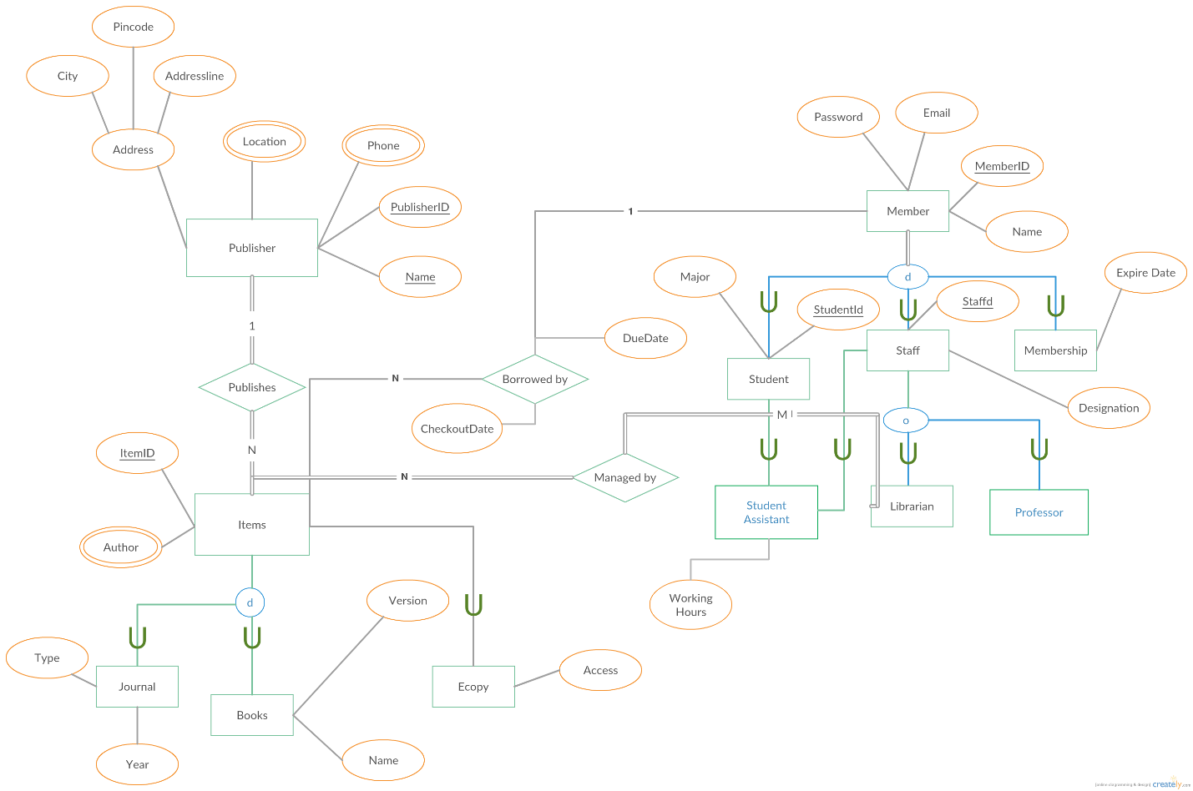

**Assumptions:**

1. One publisher can publish multiple library items.
2. Each Library items can have e-copy and it can be wither a journal or book.
3. Members will borrow books from library. Members can be either student or staff or a membership member.
4. One member can borrow multiple library items and also each library item can be borrowed by only one member at a time.
5. Student can also be a student assistant, in that case that student will also participate as staff.
6. Each librarian will manage many items in library and all the items in library has to be managed by some librarian.
7. Staff can be either student assistant or librarian or a professor.
8. **Art Museum:**
9. **Draw an EER diagram for this application. Discuss any assumptions you make.**

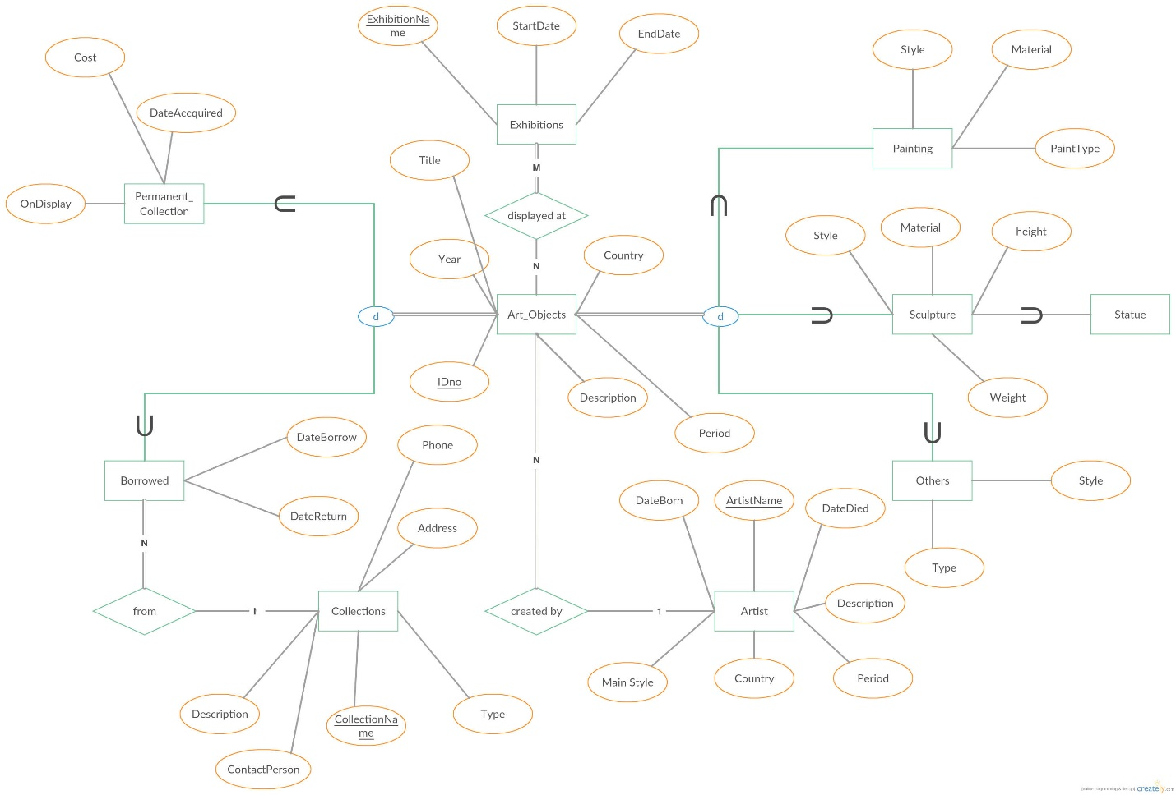

**Assumptions**:

1. Art Objects may or may not have atrist information. Each Art object will be created by at max of one artist. Each Artist can create many Art Objects
2. Each borrowed item will be from only one collections.
3. Exhibitions cannot be conducted without any art objects.

**b.Map the designed EER diagram to relational schema.**

Artist (Artistname, MainStyle, Country, DateBorn, DateDied, Period, Description)

Collections (CollectionsName, Type, Description, ContactPerson, Address, Phone)

Exhibitions (ExhibitionName, StartDate, EndDate)

Art_Objects (IDno, Description, Country, Period, Title, Year, Artistname)

Art_Exhibition(IDno,ExhibitonName)

Permanent_Collection(IDno,Cost,OnDisplay,DateAccquired)

Borrowed(IDno,DateBorrow,DateReturn, CollectionsName)

Painting(IDno,Style,Material,PainType)

Statue(IDno,Style,Material,height,weight)

Others(IDno,Style,Type)

1. Consider the ER diagram in following figure. Map the given conceptual schema to relational database schema.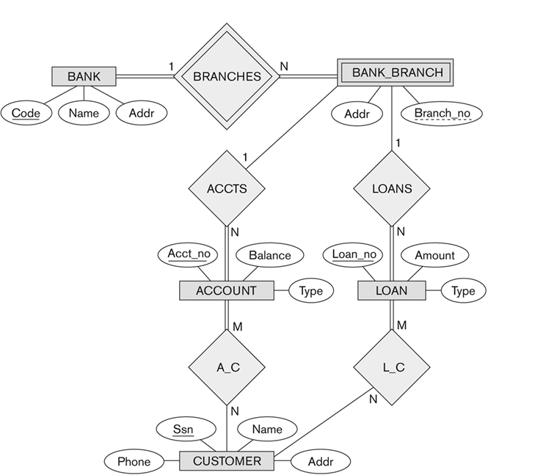

Bank (Code, Name, Address)

Bank_Branch (Addr, Branch_No, Code)

Loan (Loan_no, Amount, Type, Branch_No, Code)

Account(Acct_no,Balance,Type,Branch_No,Code)

Customer(Ssn,Name,Addr,Phone)

AccountCustomer(Ssn,Acct_no);

LoanCustomer(Ssn,Loan_no)

1. Consider the EER diagram in below figure for a car dealer. Map the EER schema into a set of relations. For the VEHICLE to CAR/TRUCK/SUV specialization, consider the four options (8A, 8B, 8C, 8D) and show the relational schema design for all options.

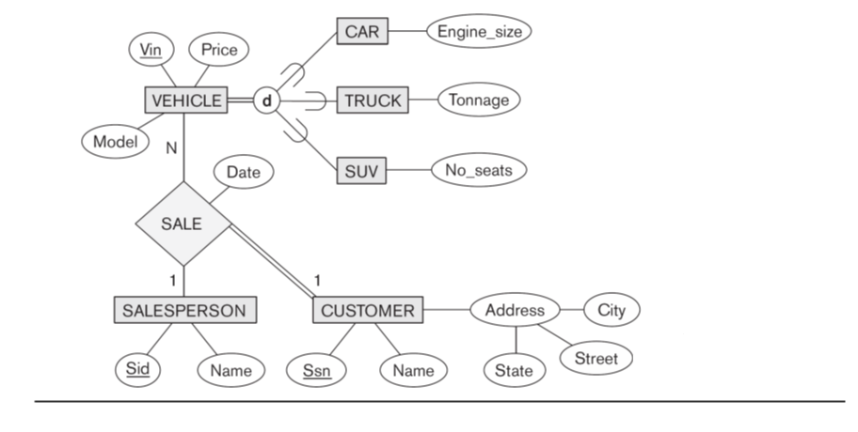

Using 8A:

Vehicle (Vin, Price, Model)

Car (Vin, Engine Size)

Truck (Vin, Tonnage)

SUV (Vin, No_Seats)

SalesPerson(Sid, Name)

Customer(Ssn,Name,City,Street,State)

Sale(Sid,Ssn,Vin,Date)

Note:

Sale relation is formed due to the terinary relation between entities.

Using 8B:

Car (Vin, Engine Size, Price, Model,sid,Ssn,saledate)

Truck (Vin, Tonnage, Price, Model,sid,Ssn,saledate)

SUV (Vin, No_Seats, Price, Model,sid,Ssn,saledate)

SalesPerson(Sid, Name)

Customer(Ssn,Name,City,Street,State)

Note:

Applied 8B and created foreign key from car,truck,suv to saleperson and customer due to the 1 to N relation between 3 relations. Saledate in the relation is moved to the N side of relation that is vechile.

**Using 8c:**

Vehicle (Vin, Price, Model, Engine Size, Tonnage, Seats,V_Type)

SalesPerson(Sid, Name)

Customer(Ssn,Name,City,Street,State)

Sale(Sid,Ssn,Vin,Date)

**Using 8d:**

Vehicle (Vin, Price, Model, Engine Size, Tonnage, Seats, C_Type, S_Type, S_Type)

SalesPerson(Sid, Name)

Customer(Ssn,Name,City,Street,State)

Sale(Sid,Ssn,Vin,Date)